YNC Board Candidates
2022-33
Candidate for Chair
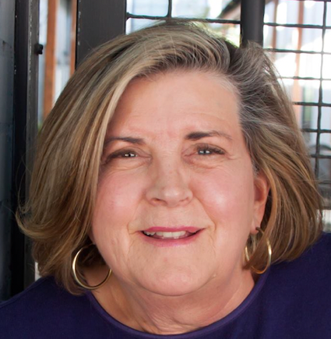
Incumbent Janet (Jan) Hemming
I’ve been a resident of Yalecrest for over 30 years and cherish our tree-lined streets, friendly folks, parks and all the dogs and dog-walkers I meet. As chair in 2021-22, I negotiated a temporary pause with Public Lands to bring greater vitality and stewardship to Miller Park. Lines of communication with the U of U have been opened about game day parking and new construction, and Yalecrest continues to be on the forefront of zoning, planning and traffic issues impacting our neighborhood.

Others who are eligible to run for chair per YNC bylaws: 2021-22 Co-Vice-Chairs Jim Webster and Rick Davis, Secretary Josh Stewart and Treasurer Libby Peterson. None have declared.

Candidates for Co-Vice Chairs
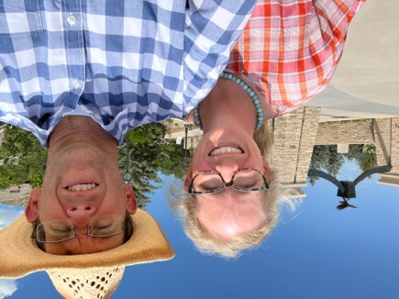
Josh Stewart (served as YNC Secretary in 2021-22). I am a long-time resident of Yalecrest and believe the YNC provides a good place to contribute to the beauty and legacy of the neighborhood. As an architect, I love the traditional homes, the charming streets and the fun parks and community stores and restaurants. As a volunteer at local schools and in my faith community, I love and admire the way our neighborhood is both welcoming and a good steward of our shared heritage and new growth.

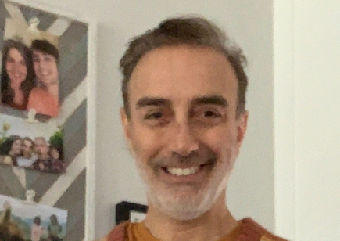
James Payor. I am a businessman involved in finance for the past 35 years including creation of a mortgage banking company with regional and national service. I grew up in New York, the second son of immigrant parents of Ecuadorian and Hungarian descent, but now live in Yalecrest with my partner who has lived most of her life in Salt Lake. My daughter and son also live in Salt Lake (Sugar House and Yalecrest). I am also an Abhaya/Anusara Yoga Instructor and a donor and advisor to a Halfway Home.

Candidates for Secretary
Tom Lund. I have spent the last 40 years in sales management at four companies: Associated Business Products/Ikon Office Solutions, EY, Zions Bank, and Tanner LLC. My wife, Gretchen, and I have lived in Harvard-Yale for 30 years and care about our community. I serve on the board of Save Our Canyons.

Candidates for Treasurer
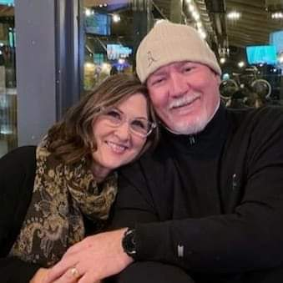
Jennifer Evans. I have lived in the Yalecrest neighborhood for 36 years. My husband Richard and I love this beautiful, historic neighborhood where we raised our two great kids. We love our neighbors and the community that we are lucky enough to be a part of. You can often find me working in my garden or out walking our pup, Seamus. I grew up in an old pioneer home in Willard, Utah which is probably one of the reasons why I feel right at home living in our "little old house" in this great historic neighborhood.

